**Web Screenshots:**

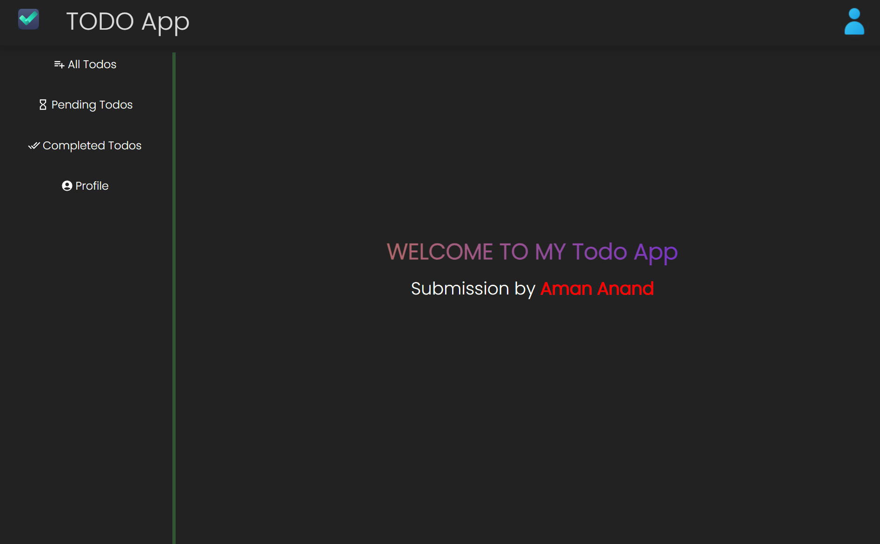

**Mobile Screenshots**

